Participatory Healthcare System

Proposer: Antoine Bagula
Abbreviation: PHSYS
Research type: Intelligent Systems and Advanced Telecommunication (ISAT)

- Brief Description:

The integration of the RFID and Sensor technologies is emerging as an important component of the first mile connectivity of the Internet called the Internet-of-Things (IoT) that allows the information to be accessed not only ‘’anywhere’’ and ‘’anytime’’ but also using ‘’anyone’’ to access ‘’anything’’. The IoT potential applications include healthcare, environment monitoring, smart cities, public safety and many other applications which might have been impossible to design without the progress made in these two technologies. A typical IoT deployment scenario consists of a proactive monitoring system where a network of RFID tags attached to objects, and a set of readers integrated into sensor motes are used as a ubiquitous sensor network (USN) [1] collecting the information on the identification and environmental parameters of these objects and transmitting this information to a gateway where the information is processed and different services derived from this information are delivered to users. This may be applied, for example, in elderly healthcare to control the amount of medicine elderly patients require and assist them in taking the prescribed type and amount of medication. It can also be deployed in a participatory healthcare management system [2,3] to help collect the information on the patient’s vital signs in a community and get this information transmitted to a server where healthcare prioritization is performed through triage in a community with limited medical practitioners. When deployed in the urban areas, such a system may be used to deliver new forms of healthcare services with less human interventions while still providing cost-effective services to both the medical practitioners and the patients.

- The Main Tasks:

The main tasks involved in this project are:

Task1: Sensing and Communication. The e-health sensor technology has matured at the point of providing least cost off-the-shelf equipment allowing capturing vital health information from a community. However research has to be done and experimentation need to be conducted in order to assess the field readiness of such equipment. Starting with a survey of different sensor technologies used in e-health networks, this project will perform in a second stage test-bed experimentation of the best sensor equipment to evaluate its field readiness when deployed for healthcare monitoring. The routing of the sensor readings collected from an e-health sensor network to a processing place is another issue that will be addressed carefully through this project to enable cost-effective deployment of this technology.

Task2: Security, trust, confidentiality and standardization. Besides field ready patient data capturing, an efficient healthcare management system requires secured data communication to avoid data tampering and other security issues which may annihilate the usefulness of the healthcare system. Furthermore, when healthcare data is concerned, privacy issues should considered with the utmost importance to avoid disclosure of vital data, which is usually highly confidential. This project will survey different security methods and standards used in healthcare data communication and build upon the most efficient to propose a secured and standardized solution for community healthcare systems.

Task3: Situation Recognition. Besides the high level of security required by a healthcare management system and the need to assess the field readiness of e-health sensor networks, situation management is an important parameter that will be addressed in this project. This will enable situation recognition, situation prediction, and patients' treatment prioritization through a triage system or graphical visualization to enable timely response and reduction in treatment cost.

Task4: Situation Management. Situation management is the next step that needs to be followed in a healthcare system to enable treatment and follow-up. This might requires participative diagnostic through voting by participant medical practitioners through the Internet or mobile communication. To achieve this objective, “group-casting” dissemination of the information will be required to disseminate the information to a specific group of doctors in a secured and trustworthy way.

Task5: Integration in existing healthcare systems using HL7 standardization.

- Computer science and research content:

- Wireless sensor:
  - Sensor classification and utilization
  - Sensor calibration
- Wireless communication:
  - Protocols classification: Zigbee, Bluetooth, Wi-Fi lite, GSM, SMS
  - Standardization: HL7 impact on communication
- Data processing:
  - Data storage: Local, Cloud
  - Data analysis: Situation recognition and Triage
- System security:
  - Secured communication: Multilayered communication
  - Datastore security: MySQL injection,
- Healthcare open source platforms:
  - Public health and biosurveillance
  - Dental management and patient record:
  - Electronic health or medical record:
  - Medical practice management software:
  - Health system management:
  - Imaging/visualization:

- Specific Learning Outcomes:

- Task 1: Sensor programming and communication protocols.
- Task 2: Network security, confidentiality and privacy, health systems standardization.
- Task 3: This task may be implemented using either an artificial intelligence approach (Task 3.1) and/or a data visualization method (Task 3.2).
  - Task 3.1 Machine learning techniques and/or Expert System
  - Task 3.2 Web services, Database management and visualization, data graphing.

- Skills required from the students working on the project:

- Theory: Statistical analysis methods, Neural networks, Bayesian Belief networks, Artificial Immune Systems, Genetic algorithms, Security protocols and encryption, database management, web services and graphics systems.
- Implementation: This is an implementation intensive project. Security mechanisms for sensor networks at both the encryption and communication protocol levels will be designed and implemented. An intelligent triage system capable of prioritization of medical information based on vital signs parameters should also be designed. Different communication protocols (ZigBee, WiFI, Bluetooth, GPRS, GSM) will be tested during this project and data capture and graphing on lightweight devices such as mobile devices, tablets and Raspberry pi will be implemented.

- Facilities Needed:

Mobile phones, Healthcare arduino kit, Alix boards, Raspberry pi or Android tablets used as gateways.

- Supervision:
Regular meetings will be scheduled for interaction with the supervisor and co-supervisors. Members of the ISAT Laboratory at UCT working on similar IoT projects can be consulted.

Number of students: 3
- One student per task
- Task 3 can be implemented using an artificial intelligence (AI) approach or a web services (WS) option depending on student’s expertise.

- Related Work [2,3]
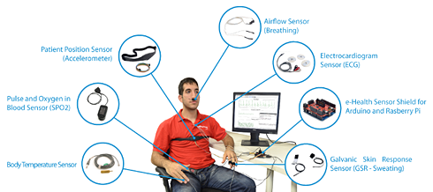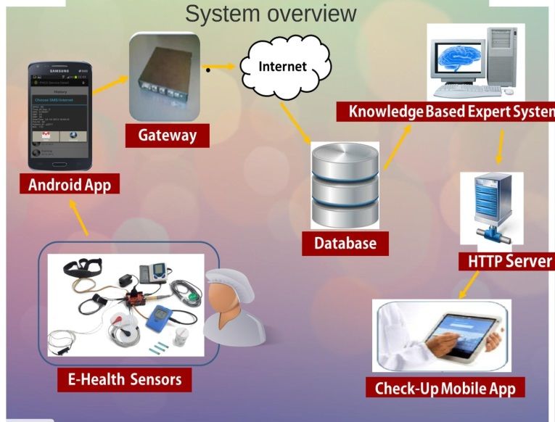
- REFERENCES.
[1] Antoine Bagula, Marco Zennaro, Gordon Inggs, Simon Scott and David Gascon, “Ubiquitous Sensor Networking for Development (USN4D): An Application to Pollution Monitoring”, Sensors ISSN 1424-8220, Vol 12, Pages 391-414; doi:10.3390/s12010039.
[2] Antoine Bagula “Participatory Healthcare System: Sensing and Communication”, Technical report, University of the Western Cape, 2014.
[3] Antoine Bagula “Participatory Healthcare System: Multi-layered Security”, Technical report, University of the Western Cape, 2014.
[4] Antoine Bagula “Participatory Healthcare System: Situation Recognition”, Technical Report, University of the Western Cape, 2014.

Appendices

- List of open-source healthcare software
From Wikipedia, the free encyclopedia
The following is a list of software packages and applications licensed under an open-source license or in the public domain for use in the healthcare industry. Software that is freely available, but not licensed under an open-source license should be placed in the List of freeware health software.
Contents
- 1 Categories
  - 1.1 Public health and biosurveillance
  - 1.2 Dental management and patient record
  - 1.3 Electronic health or medical record
  - 1.4 Medical practice management software
  - 1.5 Health system management
  - 1.6 Imaging/visualization
  - 1.7 Medical information systems
  - 1.8 Research
  - 1.9 Mobile devices
  - 1.10 Out-of-the-box distributions
  - 1.11 Interoperability testing
  - 1.12 Libraries and units
- 2 References

- Categories
Public health and biosurveillance
- Epi Info is public domain statistical software for epidemiology developed by Centers for Disease Control and Prevention.
- Spatiotemporal Epidemiological Modeler is a tool, originally developed at IBM Research, for modeling and visualizing the spread of infectious diseases.

Dental management and patient record
- Open Dental is the first open-source dental management package with very broad capabilities on record management, patient scheduling and dental office management.

Electronic health or medical record
- Bots open source edi translator^{[1]} is a cross-platform GPL licenced edi software framework. All HIPAA transactions are supported. Bots uses django; databases like MySQLand PostgreSQL are supported.
- CottageMed is a cross-platform electronic medical record system based on FileMaker. CottageMed is released under the GPL
- FreeMED is a practice management and electronic and computer records system. It allows the tracking of medical data, in detail, with preservation not just of the diagnosis but the reasons for medical encounters. FreeMED is released under the GPL
- GaiaEHR is a modern open source electronic health record developed using PHP and Ext JS.
- GNUmed is a WxPython application that uses PostgreSQL.
- GNU Health is a free, centralized, highly scalable health and hospital information system
- Hospital OS Open source hospital information system in Thai
- HOSxP is a hospital information system, including Electronic health record (EHR), in use in over 70 hospitals across Thailand.
- Mirth (software) is an open source cross-platform HL7 interface engine that enables bi-directional sending of HL7 messages between systems and applications over multiple transports.
- NOSH ChartingSystem (source code^{[2]}) is an electronic health record system and patient portal system based on Laravel (framework), PHP, and jQuery.
- openEHR is an open standard specification in health informatics that describes the management and storage, retrieval and exchange of health data in electronic health records (EHRs) following a two-level modelling paradigm.
- OpenEMR an open-source PHP-based ^{[3]} electronic medical record (EMR) system.
- OpenMRS is a community-developed, open-source, enterprise EMR framework. Extensible and scalable EMR based on Java.
- OSCAR McMaster an open-source electronic medical record (EMR) software. The billing component of the software is specialized for the needs of the Canadian health-care providers.
- THIRRA (EHR) is a web based EHR application designed primarily for narrowband. It was released under the Mozilla Public License and includes communicable diseases biosurveillance feature. THIRRA uses PHP5, CodeIgniter and PostgreSQL.
- VistA – Veterans Administrations integrated electronic health record system available for non-governmental use as OSEHRA VistA or OpenVista or WorldVistA.
- ZEPRS The ZEPRS application is an electronic patient record system that enables clinicians to enter data from patient visits using a web browser.
- SmartCare is a C# windows based EHR application, with working installations in Zambia, Ethiopia and South Africa. It is designed with the state of poor connectivity in developing countries in mind, making use of SmartCards to store patient level information. Its core development team is based in Zambia where the Government has adopted it as its national EHR.
- Rugged EHR is an open source, CDA and HL7 v3 standards based EHR. It has been designed for national and international ambulatory care providers. Out of the box Health Information Exchange (HIE) compatibility using the IHE XDR, XDS, and XCA standards. Direct Project standard secure communication. ICD-10, SNOMED, and LOINC terminology standards.
Medical practice management software
- ClearHealth covers the five major areas of practice operations including scheduling, billing, EMR, HIPAA Security and accounts receivable.
- FreeMED is a practice management and electronic and computer records system. It allows the tracking of medical data, in detail, with preservation not just of the diagnosis but the reasons for medical encounters. FreeMED is released under the LGPL GNU license. FreeMED is an HIPAA compliant FOSS practice management system that handles billing.
- GNU Health is a free, centralized, highly scalable health and hospital information system
- MedinTux MedinTux is a French medical practice management system, with a web interface as well as a desktop one, that has been initially to manage a hospital emergency department. Being very modular, it has been extended to run also many different smaller practices. It works on GNU/Linux, Mac OS X, Microsoft Windows
- Open Dental Dental practice management
- OpenEMR A free medical practice management, electronic medical records, prescription writing, and medical billing application.
- Practice Manager is an open source, CDA and HL7 v3 standards based, modern practice management system. It has been designed for national and international ambulatory care providers. Out of the box Health Information Exchange (HIE) compatibility using the IHE XDR, XDS, and XCA standards. Direct Project standard secure communication. ICD-10, SNOMED, and LOINC terminology standards.
- Prescription Pad A Medial Software that ensures 100% safe, fool-proof & first rate prescription to a patient,facility for checking drug interactions and duplication's automatically along with safety parameters like pregnancy , lactation, children, elderly, hepatic insufficiency, renal insufficiency & pulmonary insufficiency once you enter brands in the prescription writing area. A new Prescription would take even less than 2 minutes to complete.

Health system management
- DHIS Open-source district health management information system and data warehouse (license: BSD license)
- HRHIS Open-source human resource for health information system for management of human resources for health developed by University of Dar es Salaam, Department of Computer Science, for Ministry of Health and Social Welfare (Tanzania) and funded by the Japan International Cooperation Agency (JICA) (license: GPLv3)

Imaging/visualization
- Drishti is a volumetric visualisation package for viewing computer tomography data. Able to import DICOM image stacks.
- Endrov Image and data viewer and editor
- ITK segmentation and registration toolkit
- InVesalius 3D medical imaging reconstruction software
- ITK-SNAP Interactive software for 3D image navigation, annotation and automatic segmentation
- Ginkgo CADx Cross-platform open source DICOM viewer and dicomizer.
- MITK - Medical Imaging Interaction Toolkit for interactive medical image processing.
- Orthanc – Lightweight, RESTful DICOM store
- OsiriX – 3D DICOM medical viewer for Mac OS X. Complete DICOM Viewer with DICOM network support
- ParaView large-scale visualization tool
- 3DSlicer Platform for medical image visualization and algorithm development. DICOM support, segmentation and registration, Diffusion MRI processing, and image guided surgery support.
- Voreen volume rendering engine—a library for visually exploring volume data sets. DICOM is supported and Voreen is used in medical visualization as well as for visualizing electron microscopy data.
- VTK visualization toolkit
- Xebra (medical imaging software)
- GIMIAS workflow-oriented environment focused on biomedical image computing and simulation
Medical information systems
- Caisis is a web based information system for the storage and analysis of cancer patient data intended to bridge the gap between clinic and research (license: GPL)

Research
- LabKey Server is an extensible platform for integrating, analyzing and sharing all types of biomedical research data. It provides secure, web-based access to research data and includes a customizable data processing pipeline.

Mobile devices
- Ushahidi Allows people to submit crisis information through text messaging using a mobile phone, email or web form. Displays information in map view.

Out-of-the-box distributions
- BioLinux
- Debian-Med
- Ubuntu-Med

Interoperability testing
- The Office of the National Coordinator for Health Information Technology (ONC) tasked MITRE with developing an open-source program called Cypress to test EHR software for compliance with the Meaningful Use Stage 2 Clinical Quality Measures.^{[4]}
- The Certification Commission for Healthcare Information Technology (CCHIT) and MITRE developed an open-source program called Laika to test EHR software for compliance with CCHIT interoperability data standards, including the HITSP C32 XML and HL7 v2 Lab messages.

Libraries and units
- PUMA Repository,^{[5]} a collection of Pascal units for medical informatics, including a converter for units of measurement and an HL7 engine.

- Free software portal
- Electronic medical record
- eHealth
- Gello Expression Language
- Health informatics
- Hospital information systems
- List of freeware health software
- List of open-source bioinformatics software
- mHealth

- References
  - http://bots.sourceforge.net
  - http://github.com/shihjay2/nosh-cs
  - http://open-emr.org/wiki/index.php/Development_Policies#PHP
  - http://ehrintelligence.com/2012/10/17/onc-open-source-cqm-ehr-certification-tool-cypress-now-available/
  - http://puma-repository.sourceforge.net

